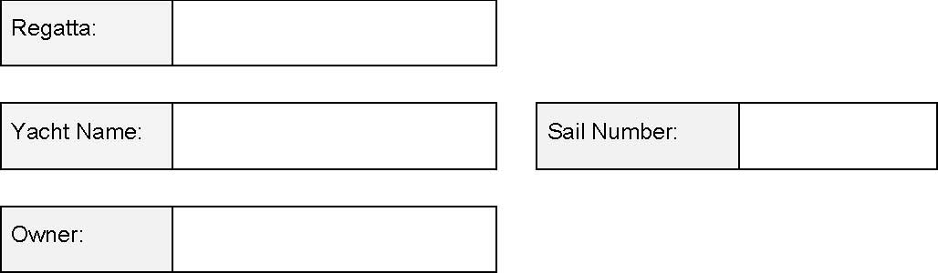

SAIL DECLARATION FORM

 | Manufacturer / Year | Button Number
Mainsail
Jib #1
Jib #2
Jib #3
OSR Heavy Weather Jib |  | N/A
Asymmetric Spinnaker # 1
Asymmetric Spinnaker # 2
Asymmetric Spinnaker # 3

I declare that the sails listed above, which comply with the McConaghy 38 One Design Rule and carry the designated sail button, will be used for the Regatta listed above.
Signature:
Name (if not owner)
Date:

Office Use:
Received: Date: _______________________________________ Date: ___________________
Sail Register check: ________________________________________ Date: ___________________

